Wave 4 Bill Test
- In the home page – need to have the OTP as follows :
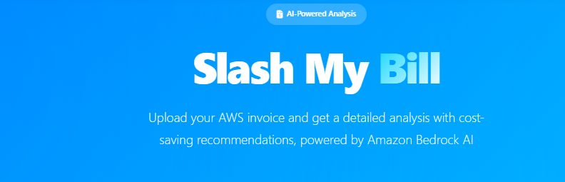
Customer enters the Full name, email and phone. At this point – the “Choose a PDF file” and the button “Revise my Bill” are greyed out.
Then – after entering the information – Click “Verify my email’ and then a message is sent to the email with OTP , valid for 5 minutes.
After that , the customer can drag and drop a Bill , then click the button – “Slash My Bill” (CURRENTLY THE TEXT IS “Revise My Bill “ – it should change to “Slash My Bill”
Report Modifications:

- Increase the icon – twice as big
- The header – please shift the text a bit up
  - Here is a bad example (current)
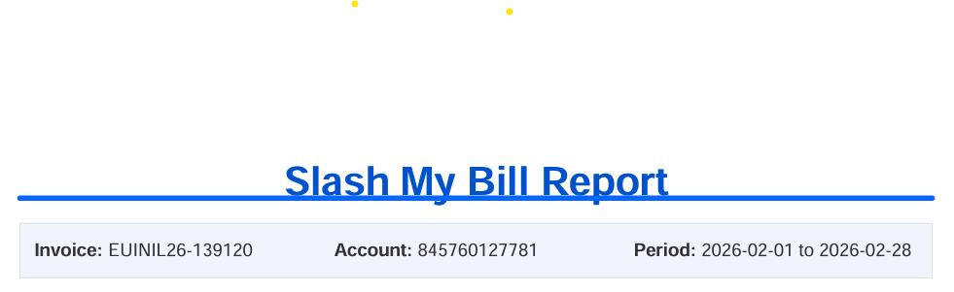
  - Here is a good example (The text went up – but need to remove the underline of the text )
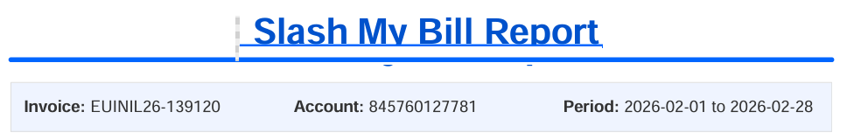
- Insert a pie chart graph after the Bill Summary text – with the % of the service consumption – display all services above 1% and anything below 1% just display “other”. Anyhow it need to be clustered together.

- When the report is ready – it should download it and not open it !

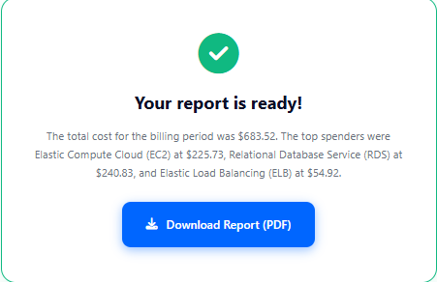

- When downloading the file name should be “SlashedReport<Date><accountName>”

